University of Computer Studies, Taunggyi

2022-2023 ACADEMIC YEAR

PROJECT REPORT FOR CST-2155



TOMORROW X TOGETHER KPOP IDOL GROUP

By

Ceasar Hlaing (2CS-3)

February, 2023

SUMMITTED BY

Second Year(B.C.Sc*)*

ACKNOWLEDGEMENT

We would like to express our gratitude to all persons who directly or indirectly contributed towards the success of our project.

Thanks are due to Dr. Khin Sandar Aung, Pro Rector, University of Computer Studies, Taunggyi, for her kind permission to develop this project and her valuable ideas and suggestion.

Our sincere thanks and respect to Dr. Khin Zezawar Aung, Head of Information Technology Supporting and Maintenance Department, University of Computer Studies, Taunggyi for her invaluable guidance, administrative support.

We thank to Daw War War Khaing, Department of Information Technology Supporting and Maintenance, University of Computer Studies, Taunggyi for administrative supervision and providing helpful guidelines during the period of preparing of this project.

Special thanks are due to our parents for their kindness and assistance, our gratitude and respect go to all our teachers for their helpful recommendations at all our seminars, we are grateful to our teachers, friends and staff members of University of Computer Studies, Taunggyi for their contribution towards the completion of this project.

ABSTRACT

K-pop is a fusion of synthesized music, sharp dance routines and fashionable, colorful outfits. Songs typically consist of one or a mixture of genres such as pop, hip hop, R&B, experimental, rock, jazz, gospel, reggae, electronic dance, folk, country, disco and classical on top of its traditional Korean music roots.

There are so many popular idol groups in the world who are famous in acting, singing, performing, modeling, so many hobbies. I want to talk about TOMORROW X TOGETHER (TXT) k-pop idol group, is a South Korean boy band formed by Big Hit Entertainment, now known as Big Hit Music.

**CHAPTER (1)**

**INTRODUCTION**

* 1. **Introduction**

This project is about the information of Tomorrow X Together and TXT is a 5-members boy group formed by Big Hit Music (part of HYBE Labels). The group consists of: Yeonjun, Soobin, Beomgyu, Taehyun and Huening Kai. They debuted on March 4th, 2019 with their first mini-album ‘The Dream Chapter: STAR’. This project contains their released albums, songs and has a website you can buy albums, merch, concert tickets.s

* 1. **Objectives**
* To know their life style
* To listen their songs
* To watch their music video and dance
* To look their images

**CHAPTER (2)**

**BACKGROUND OF THE PROJECT**

2.1 **Background of the project**

About the K-pop idol group , you can view various sections that provide information about the TXT K-pop group, such as their history, members, discography and upcoming events. This website also include multimedia content, such as music audio, photo, weverse shop page and payment page. The website project is to create a platform where fans can connect with their favorite group and stay informed about their activities and releases.

This project is made of the first time. Completing a project is just the beginning of my journey. I learned many valuable things from this experience. I will try to improve my skills. I hope, users will enjoy my website.

**CHAPTER (3)**

**IMPLEMENTATION**

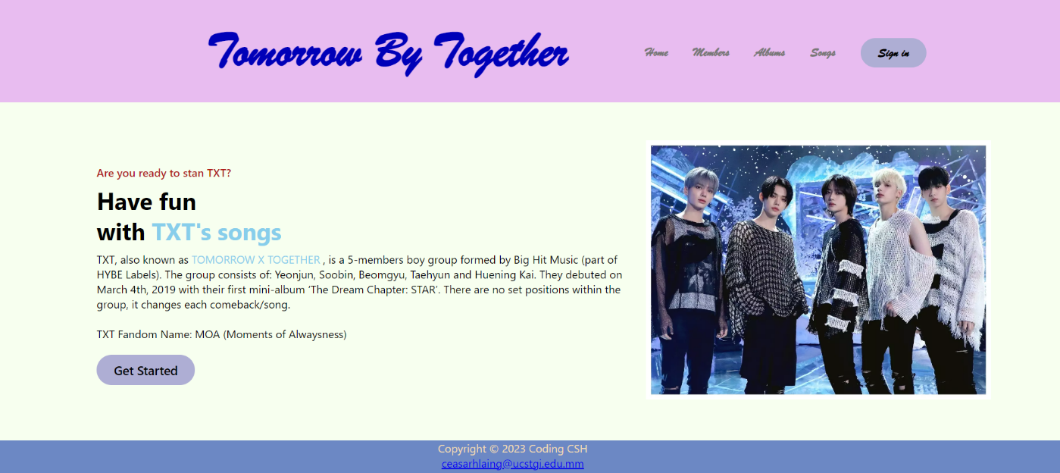

**Figure 3.1 Home Page**

At home page describes the information of the TXT group. If you want to know about the members go to Members Page.

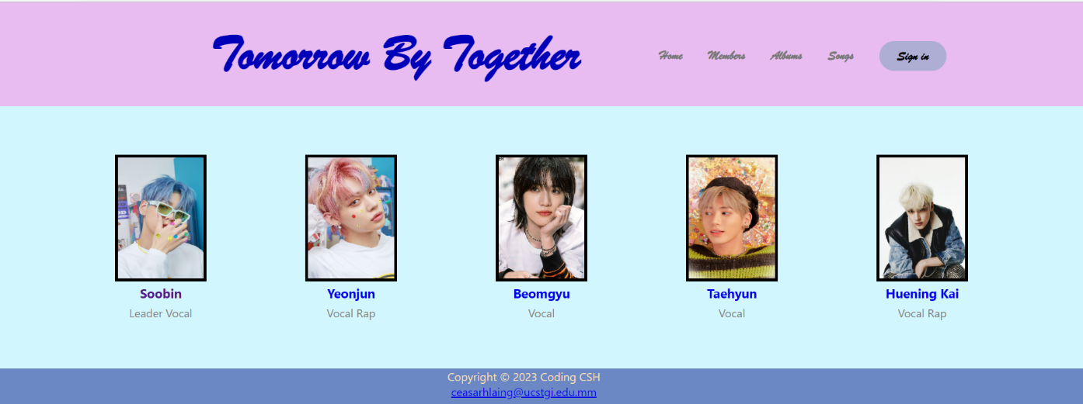

**Figure 3.2 Members Page**

This page includes the members of TXT. If you click on “Soobin” , you will reach to another page including his profile and facts ….another members are also like that.

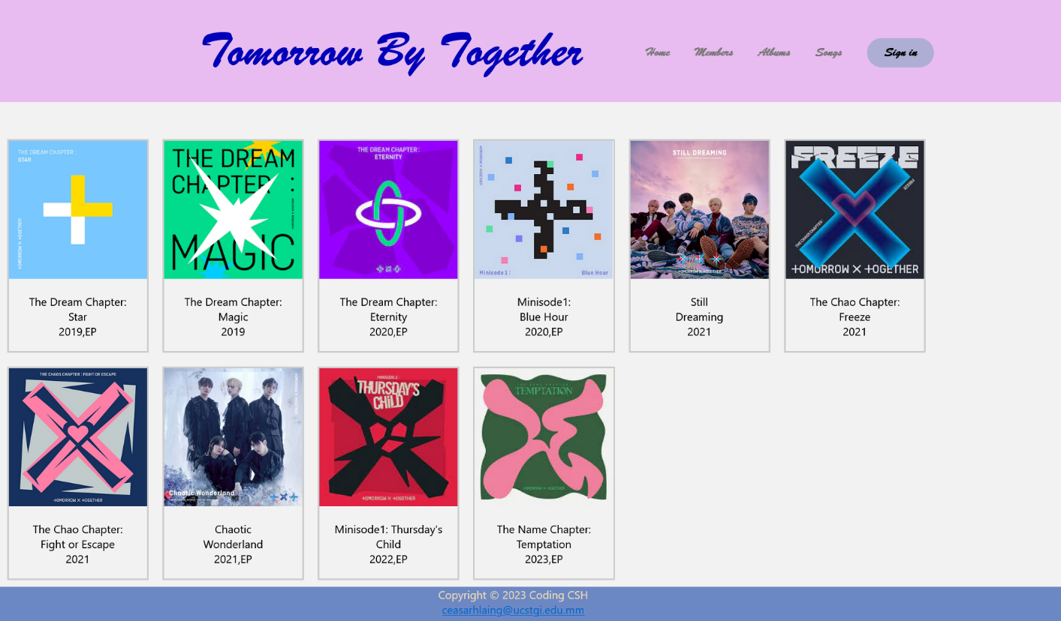

**Figure 3.3 Albums Page**

Figure 3.3 Albums Page, you will see the released albums of TXT group

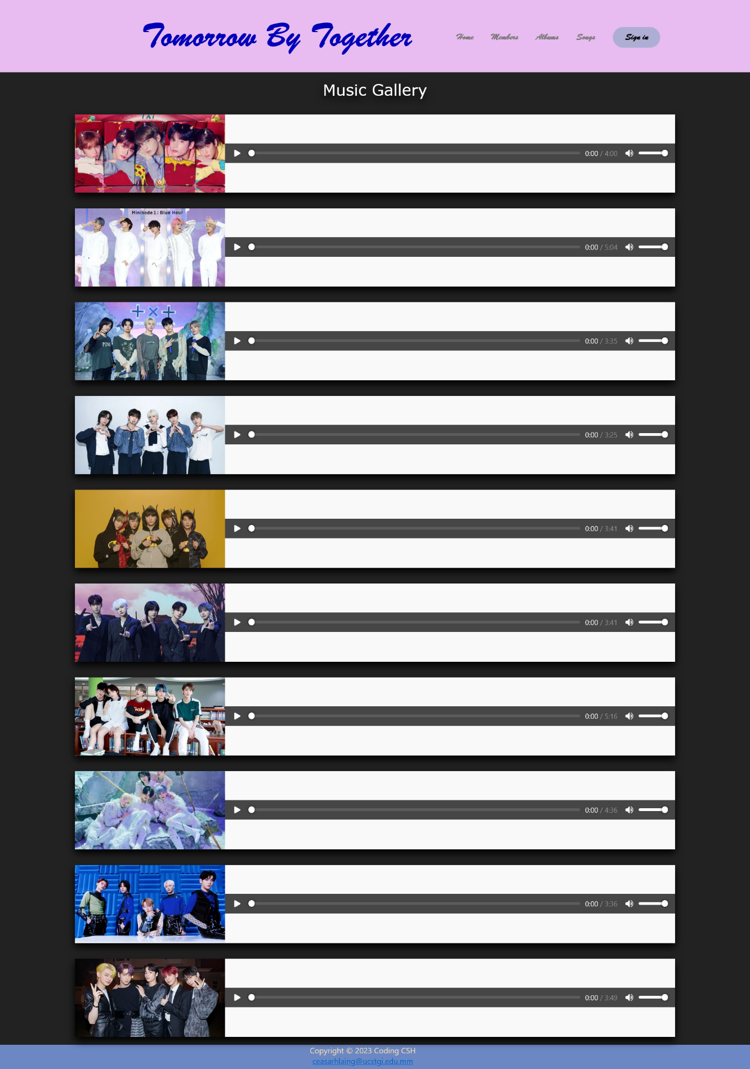

**Fig 3.4 Songs Page**

This page includes some of their songs. I added audios so that you can listen to the music and you can increase or decrease the volume as you wish.

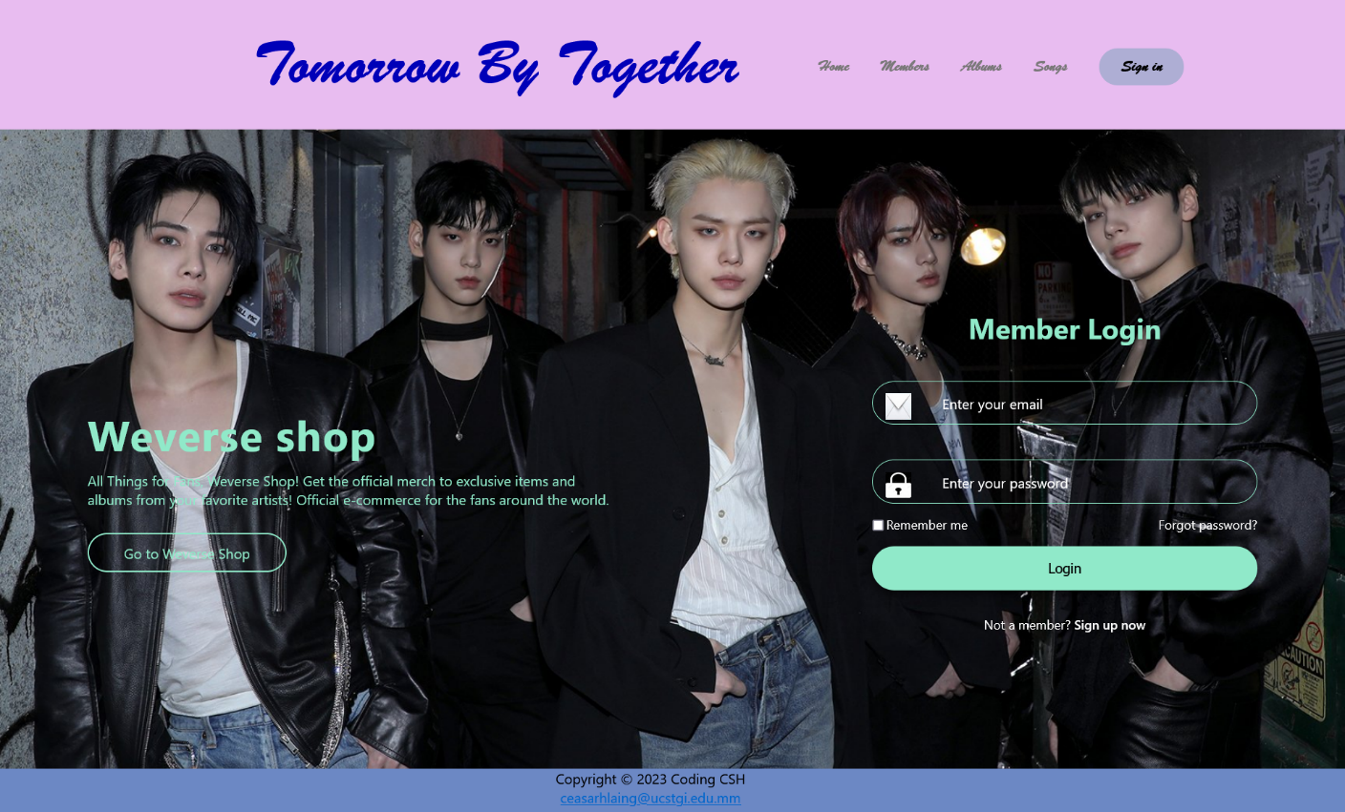

**Fig 3.5 Sign in Page**

In this page, you can login to Weverse Shop where you can buy items related to them. If you click on “Sign up now or Go to Weverse Shop” , you will reach to Weverse Shop page.

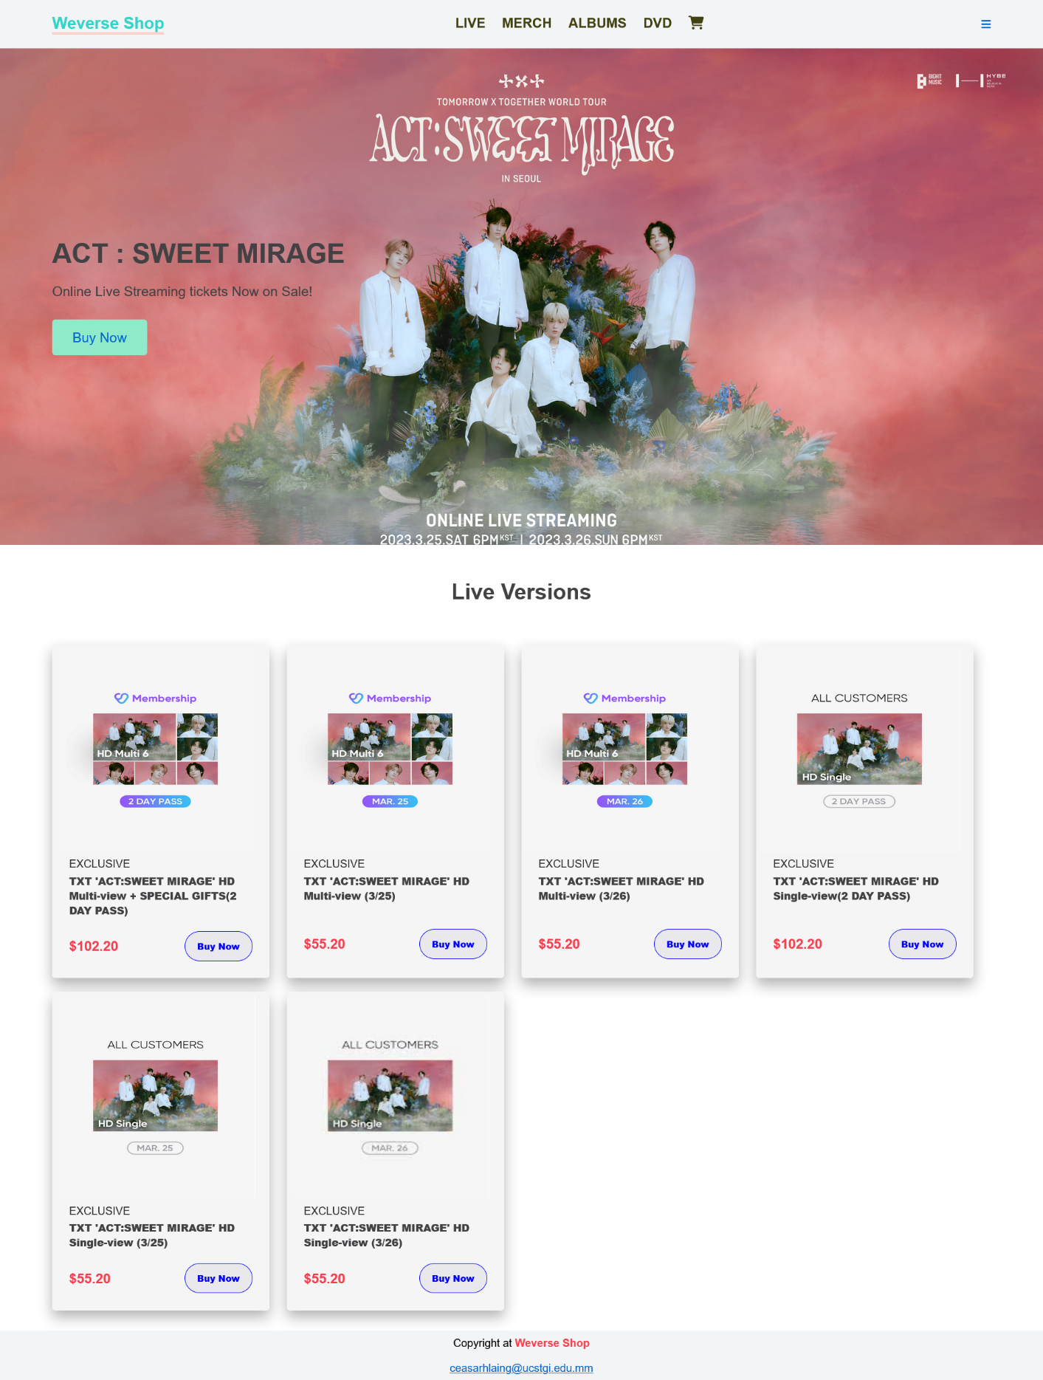

**Fig 3.6 LIVE Page**

Welcome to Weverse Shop! In this page, you can buy their online concert tickets. If you click on “Buy Now” , you will reach to Payment page.

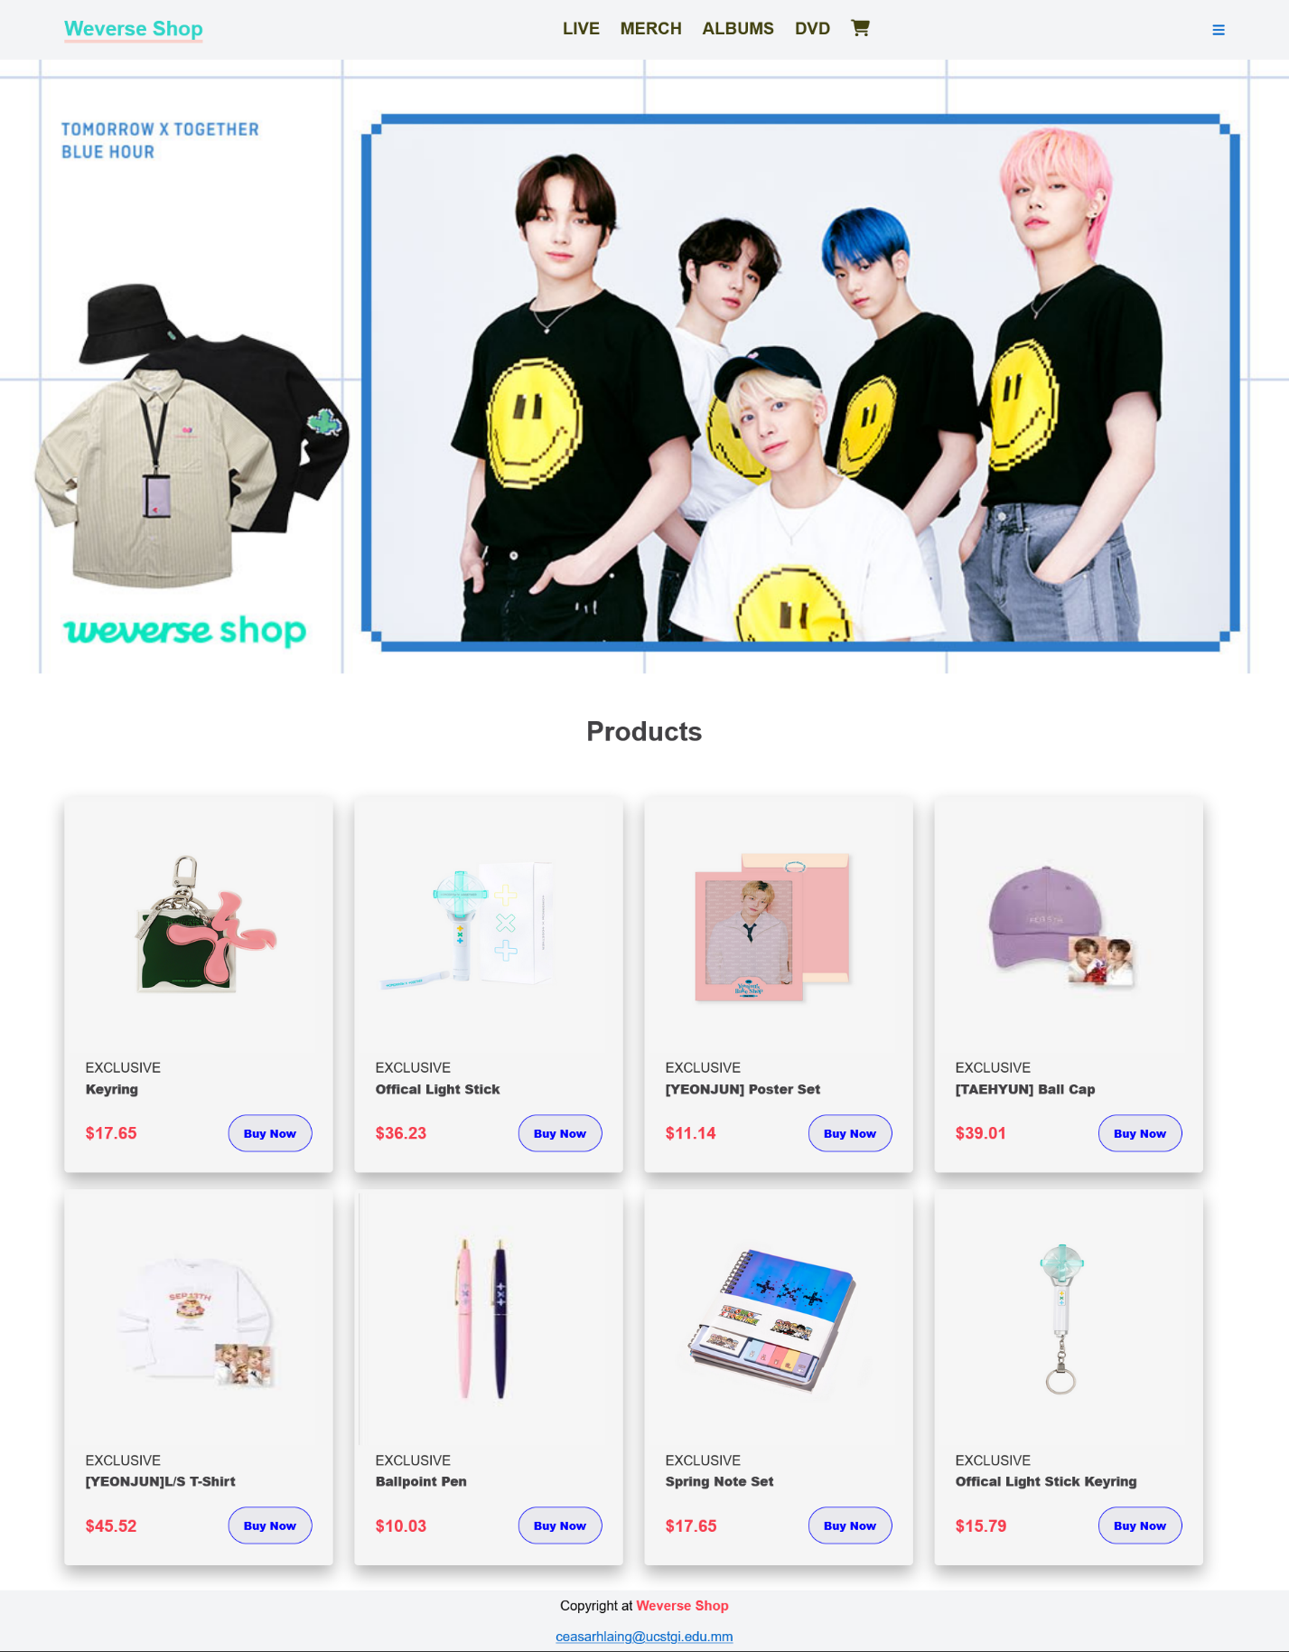

**Fig 3.7 MERCH Page**

Welcome to Weverse Shop! In this page, you can buy their products. If you click on “Buy Now” , you will reach to Payment page.

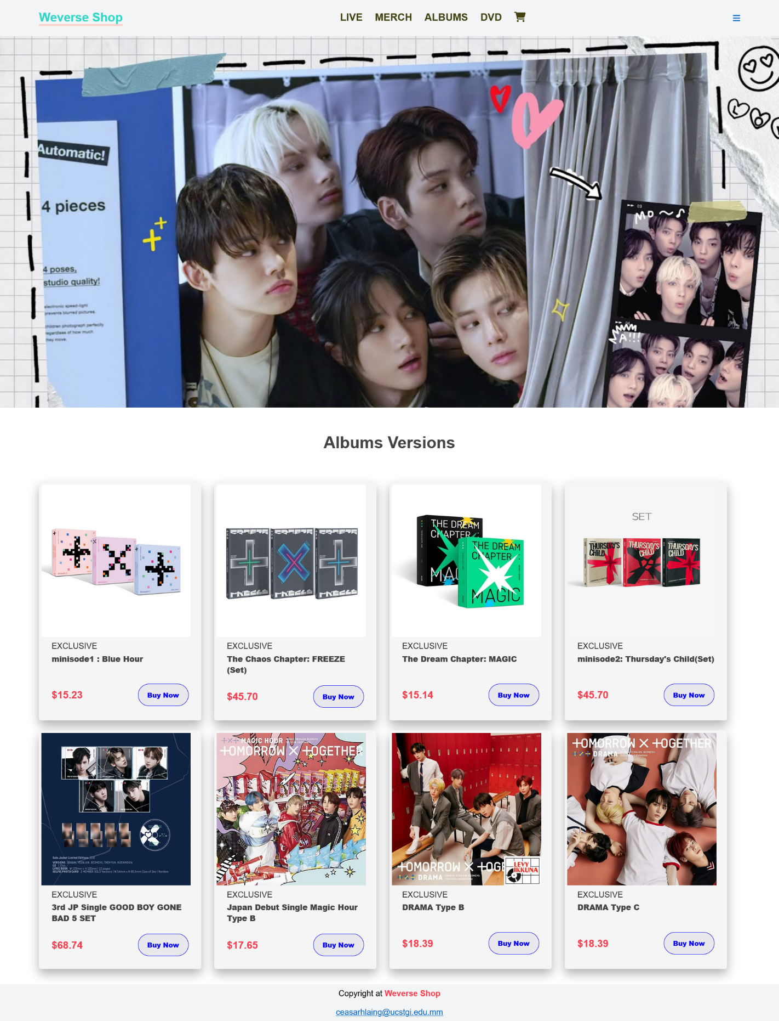

**Fig 3.8 ALBUMS Page**

Welcome to Weverse Shop! In this page, you can buy their released albums. If you click on “Buy Now” , you will reach to Payment page.

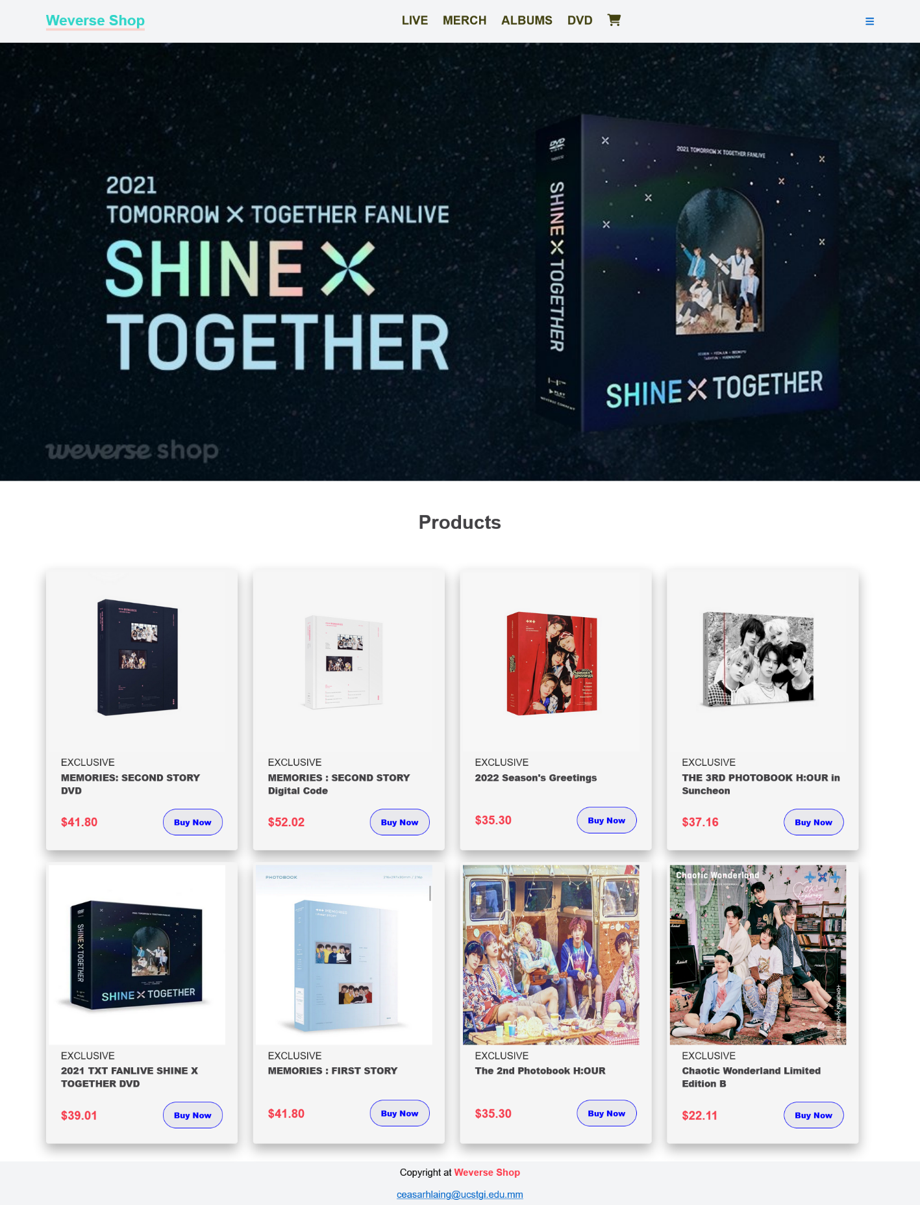

**Fig 3.9 DVD Page**

Welcome to Weverse Shop! In this page, you can buy their released DVD. If you click on “Buy Now” , you will reach to Payment page.

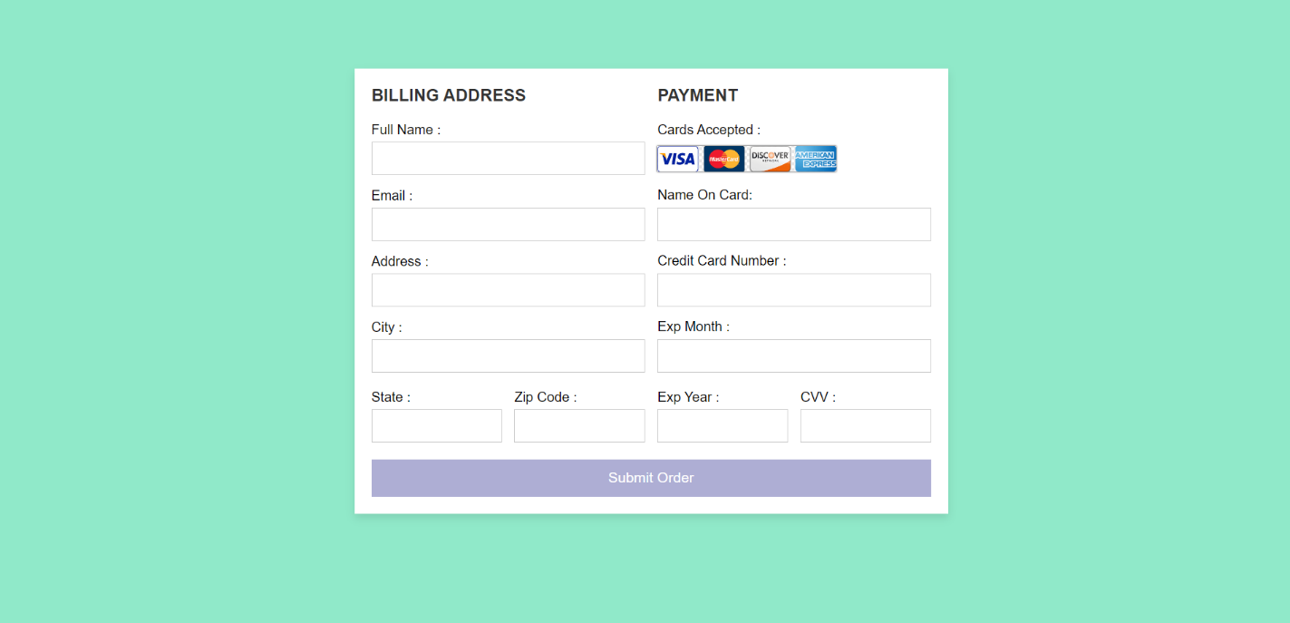

**Fig 3.10 Payment Page**

This page is where you can pay for the items you will order.

**CHAPTER (4)**

**CONCLUSION**

In this project, you can find information about Tomorrow X Together (TXT). You can listen to their songs and you can easily buy their released albums, online concert tickets and products. I hope everyone will support TXT K-pop idol group, they are a young and talented group.

**REFERENCES**

1. <https://www.youtube.com>
2. <https://www.google.com>